Daliah Aljutayli

**Find out your IP address using CLI**

$**config** <- display **information** about **all network interfaces** currently in the OS.

$**ip a** or **ip addr** <- **displays addresses** and their properties + adds new and deletes addresses.

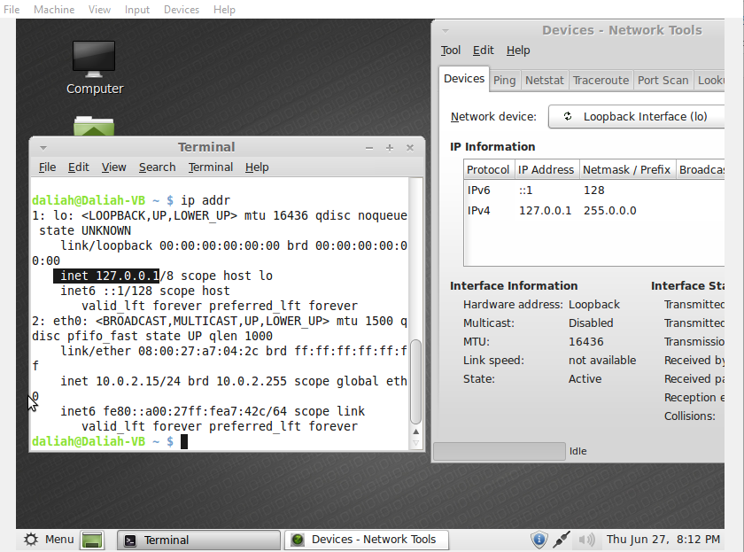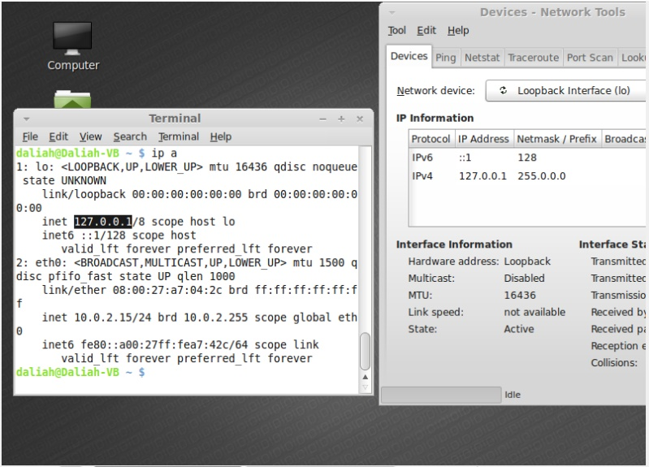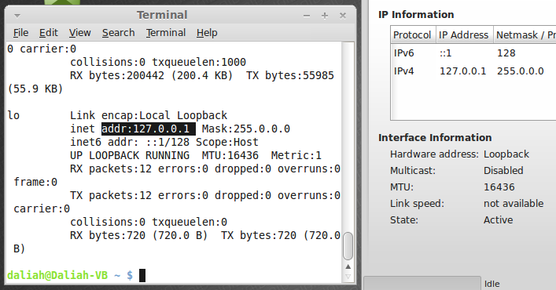

Video in YouTube: <https://www.youtube.com/watch?v=lCbXSYQyrzY&feature=youtu.be>

**Change your VM host name**

$ **hostname** <- display Current hostname

$ **sudo nano /etc/hostname** <- Change the current hostname

Click **ctrl + x** to exit and enter **Y** to yes

$ **hostname** <- display Current hostname (The new hostname after change it)

Video in YouTube: <https://www.youtube.com/watch?v=O4LDb4J_eMg>

**Ping to** [**google.com**](http://google.com) **for 5 times (use only one command).**

$ **ping -c 5 google.com** <- ping to google.com 5 times (**-c** tells ping program to stop after sending specific number = 5)

Video in YouTube: <https://www.youtube.com/watch?v=BiavR06UWmY&feature=youtu.be>

**Every time the user wants to visit** [**www.google.com**](http://www.google.com) **,send them to** [**fortydays.sa**](http://fortydays.sa) **.**

**SSH to one of the Linux VM’s that you installed from your host computer**

From windows **cmd** to Ubentu **CLI** : >**ssh daliah@192.168.56.104 -p 22**

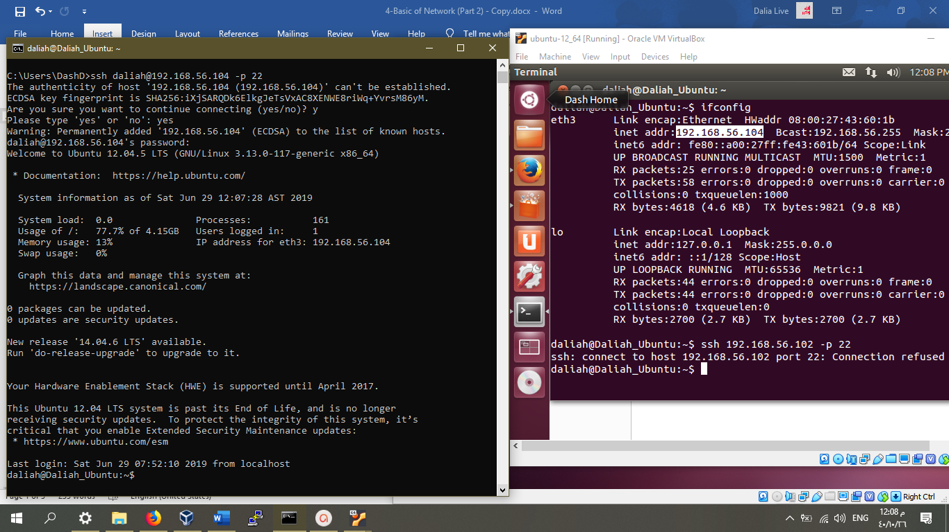

**SSH from VM to your host computer (opposite).**

$ssh Daliah-PC@192.168.0 .3 -p 22

-enter public-key

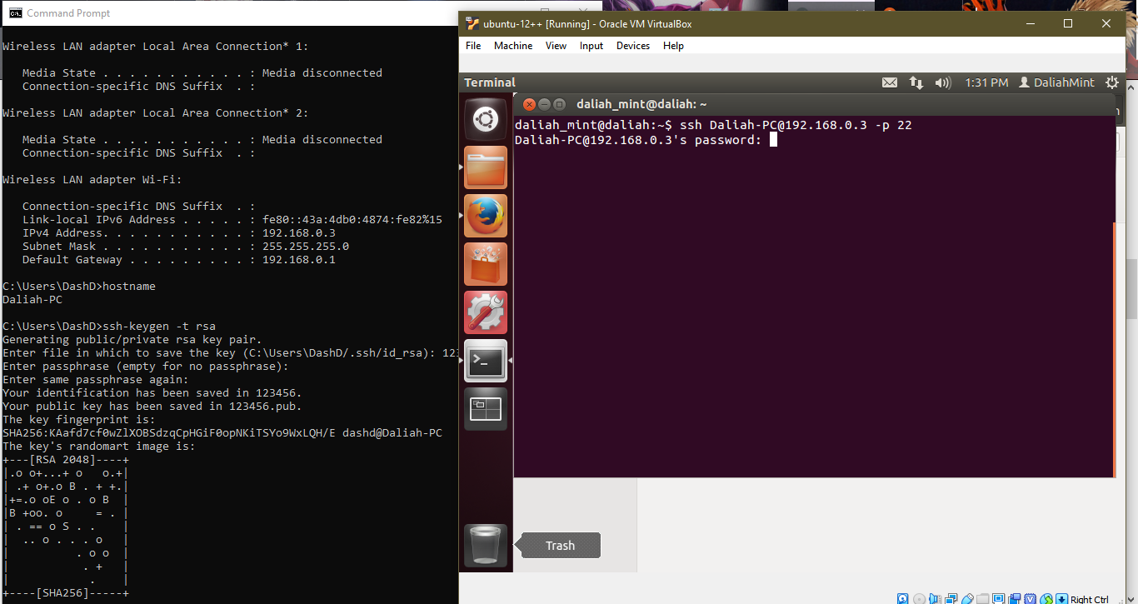

**Install a chat application on a virtual machine, and then install a client in another virtual machine and try to communicate between them.**

**$nc ip_address port_number**

**client: $nc -l -p port_namber**

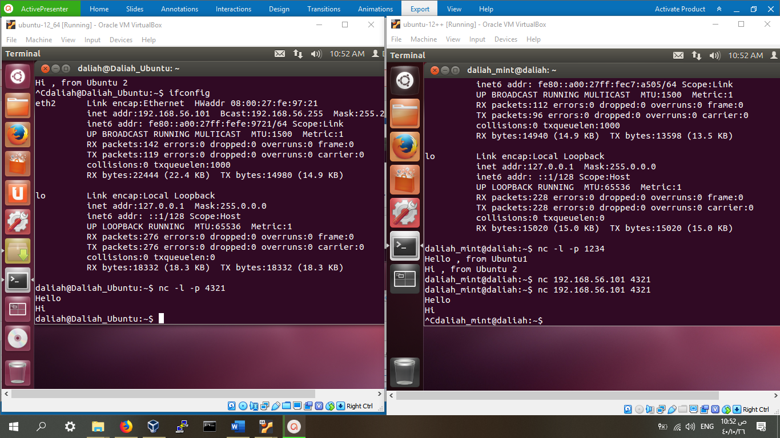

Video in YouTube: <https://www.youtube.com/watch?v=2EQhowrRZnM>